Backups

Ben Peal

March 23, 2004

Table of Contents

Specifications 3

Emergency Contact Information 4

Client And Profile List 5

Terminology 8

Operational Procedures 10

Data Retention 12

The NetBackup Administration Console 13

Activity Monitor 15

Reports 17

Adding New Tapes To The Library 19

Removing Tapes From The Library 21

Restoring A File 23

Creating A Backup Policy 28

Adding New License Keys 36

User-Directed Backup For Unix 37

User-Directed Backup For Windows 38

Installing NetBackup On A Unix Client 39

Installing NetBackup On A Windows Client 40

Modifying the Registry 41

Installing Database Agents 42

Troubleshooting 43

Specifications

SERVER
1 x Sun Fire 280Rse (SN S207C019D)
2 x Sun 36.4 GB HD (mirrored/RAID1)
1 x Sun PG x 64 graphics card
1 x Sun SCSI card
1 x Sun Keyboard, Mouse, and Accessory Kit
1 x Sun 17-inch Entry Color Monitor (SN 0206LR0037)

LIBRARY
1 x StorageTek L40 Tape Library (SN 468000101445)
1 x 40-cell personality module
2 x Seagate Viper 200 Tape Drive (SN HM0081K) (SN HM00663)
1 x Seagate Viper 200 Installation Guide/Manual CDROM
1 x Redundant Power Supply (2 power supplies total in library)
1 x SCSI cable (68MD-68MD, 500mm)
2 x SCSI cable (68MD-68MD, 3mm)
2 x SCSI terminator
Ultrium tapes: Maxell Ultrium 1 LTO (Linear Tape Open) 100GB tape
2 x LTO cleaning tape

OPERATING SYSTEM
Solaris 8

SOFTWARE
VERITAS NetBackup BusinessServer 4.5 for Unix
GNOME 2.0 Desktop - Beta 1

SERVICE CONTRACTS
One-year VERITAS NetBackup service contract (customer id #173556)

Emergency Contact Information

Orange
systems@orange.us
timothy@orange.us

VERITAS
Re: VERITAS NetBackup tech support
1-800-342-0652
Customer ID #173556
Customer Name: Orange

Iron Mountain
Re: Offsite tape storage
781-273-9500
Orange customer id# 7004
Service day: Wednesday
Service (aka tape pickup) time: 9am - noon.

Network Information Systems (NIS)
Re: Tape library and server vendor
TJ Costello – tjc@netinfosystems.net
Tom Gorsuch – tgorsuch@netinfosystems.net
781-932-0073 x225

StorageTek
Re: support for tape library
Warren Hirst – HirstWL@NORTHAMERICA.Stortek.com
Warren_hirst@storagetek.com
1-800-535-0369

Client And Profile List

This is the list of clients that are currently being backed up. The client names are listed first, with their respective backup profiles. The details of the backup profiles follow, and include the schedule, file list, and volume pool for each profile.

Name Operating System Profiles
betelgeuse Solaris 8 BetelgeuseFull
BetelgeuseIncr

dev Solaris 8 SolarisFull
SolarisIncr

polaris Solaris 8 SolarisFull
SolarisIncr

mandarin RedHat 2.2 LinuxFull
LinuxIncr

pipes RedHat 2.2 LinuxFull
LinuxIncr

spv RedHat 2.2 LinuxFull
LinuxIncr

franklin RedHat 2.2 LinuxFull
LinuxIncr

americium RedHat 2.2 LinuxFull
LinuxIncr

pummelo Windows 2000 WindowsEtcFull
WindowsEtcIncr

seville Windows 2000 WindowsEtcFull
WindowsEtcIncr

sanguinella Windows 2000 WindowsEtcFull
WindowsEtcIncr

boston Windows 2000 WindowsEtcFull
WindowsEtcIncr

ruby Windows NT WindowsEtcFull
WindowsEtcIncr

invincible Windows XP WindowsEtcFull
WindowsEtcIncr

centurion Windows XP WindowsEtcFull
WindowsEtcIncr

indomitable Windows XP WindowsEtcFull
WindowsEtcIncr

dreadnought Windows XP WindowsEtcFull
WindowsEtcIncr

valiant Windows XP WindowsEtcFull
WindowsEtcIncr

tangelo Windows XP WindowsEtcFull
WindowsEtcIncr

inflexible Windows XP WindowsEtcFull
WindowsEtcIncr

indefatigable Windows XP WindowsEtcFull
WindowsEtcIncr

nova Windows 2000 ExchangeMailboxFull
ExchangeMailboxDiff

valiant Windows XP ExchangeStoreDiff
ExchangeStoreFull

Backup Profiles

Profile Name Files Schedule Volume Pool
BetelgeuseFull / Sun 00:00-23:00 SolarisFull
/opt
/export/home

BetelgeuseIncr / Mon-Fri 00:00-24:00 SolarisIncr
/opt Sat 00:00-23:00
/export/home

SolarisFull / Sun 00:00-23:00 SolarisFull
/opt
/export/home

SolarisIncr / Mon-Fri 00:00-24:00 SolarisIncr
/opt Sat 00:00-23:00
/export/home

LinuxFull / Sun 00:00-23:00 LinuxFull
/usr
/home

LinuxIncr / Mon-Fri 00:00-24:00 LinuxIncr
/usr Sat 00:00-23:00
/home

WindowsEtcFull ALL_LOCAL_DRIVES Sun 00:00-24:00 WindowsEtcFull
Mon 00:00-06:00

WindowsEtcIncr ALL_LOCAL_DRIVES Mon-Fri 00:00-24:00 WindowsEtcIncr
Sat 00:00-23:00

ExchangeMailboxFull Microsoft Exchange Mailboxes:\ Sun 00:00-12:00 WindowsExchangeFull
Fri 22:00-24:00
Sat 00:00-24:00

ExchangeMailboxDiff Microsoft Exchange Mailboxes:\ Sun 12:00-24:00 WindowsExchangeFull
Mon-Fri 00:00-06:00
Mon-Fri 22:00-24:00
Sat 00:00-06:00

ExchangeStoreFull Microsoft Information Store:\* Sun 00:00-12:00 WindowsExchangeFull
Fri 22:00-24:00
Sat 00:00-24:00

ExchangeStoreDiff Microsoft InformationStore:\* Sun 12:00-24:00 WindowsExchangeFull
Mon-Fri 00:00-06:00
Mon-Fri 22:00-24:00
Sat 00:00-06:00

Terminology

Active Policy – A backup policy that has been set to “active”, that is, currently in effect and operational.

Cartridge Access Port (CAP) – The small door of the robotic tape library from which tapes are removed from the library. Also known as the Media Access Port (MAP).

Client – A machine for which data must be backed up.

Full Backup – A backup that backs up all files, regardless of whether or not they had changed.

Incremental Backup – A backup that only backs up files that had changed and brand new files.

Library – The robotic tape library, in which the backup tapes are stored and used.

Media Access Port (MAP) – The small door of the robotic tape library from which tapes are removed from the library. Also known as the Cartridge Access Port (CAP).

Media Server – The server that controls the robotic tape library and tape drives.
In this case, it’s the same as the NetBackup Server and the Master Server, both of which are polaris.

Open Transaction Manager (OTM) – The software running on all Windows clients that are not running MS Exchange that allows backups of files that are currently open.

Policy – The list of files and clients, and the schedule for a given group of backups

Retention – The plan for storing backup tapes offsite, including the duration for which backup data is kept.

Rotation – The plan for moving tapes out of the library, sending those tapes to off-site storage, and adding new tapes to the library.

Schedule – The days, times, and start windows during which backups are to occur for a given policy.

Server – The machine which manages the operation of backups, and on which the NetBackup server software is installed and running. In this case, it is polaris.

Start Window – The period of time in which backups are allowed to occur.

Storage Unit – A backup tape drive.

Volume – Another name for a backup tape.

Volume Pool – A group of tapes in which a certain kind of data (ex. Unix, Windows, Exchange) is stored.

Operational Procedures

Daily Tasks

Every day from Monday to Saturday, incremental backups run.

The final status (and status code) for each backup job is sent by email to systems@orange.us. Check this mail every day to confirm that backups are running correctly. Alternately, consult the Activity Monitor (see Activity Monitor) to see the final status for the previous night’s jobs.

Weekly Tasks

Every Sunday, full backups run.

Every Wednesday between 9:00 am and noon, an Iron Mountain courier arrives to collect tapes for off-site storage. On Tuesday, remove tapes that have data on them (see Tape Removal) and insert new tapes into the library (see Tape Insertion). Fill out an Iron Mountain manifest (ask Tim Balcer or Michael Cappelletti for one), including the company name (Orange), the customer ID (7004), and the number on each tape. Give the manifest and the tapes to the front desk for pickup on Wednesday. If you’re running low on fresh backup tapes, order more.

Yearly Tasks

Every year, the VERITAS support contracts need to be renewed. Contact Michael Cappelletti and tell him to renew the contracts.

Every year, the cleaning tape in the library needs to be replaced. Order a new one, take out the old one, and put in the new one.

Disaster Recovery

If a file is lost or damaged, restore the file (see Restoring A File). If the file that was lost or damaged is more than a week old, you will need to contact Iron Mountain to have the appropriate tape sent back to Orange in order to restore the file.

If an entire client machine is lost, purchase a new machine, give it the same operating system, and give it the exact same name as the old machine. Install the NetBackup client on the machine (see Installing NetBackup On A Windows Client or Installing NetBackup On A Unix Client, depending on the operating system). Once that is done, restore all of the files that were on the old client onto the new machine (see Restoring A File, and you will likely want to not restore the old system files – consult your local sysadmin, Tom Mullaly, about this).

If the NetBackup server (polaris) is lost, purchase an identical system (see Specifications), or a compatible system (as new and improved versions of the hardware are introduced to the market all the time), and have your local sysadmin, Tom Mullaly (or perhaps a hired contractor), configure the system and install the NetBackup server software. Then contact VERITAS tech support (see Emergency Contact Information) and have them guide you or your local sysadmin throught the process of restoring the original server data.

Data Retention

We've currently set the backup policies to have a retention period (the duration for which you wish to keep the backup data) of 1 year, and a rotation period (the rate at which you wish to move tapes from the library to the storage facility) of one week. Both full backups and incremental backups have a one-year retention period, as day-to-day changes in files are likely critical to this company. As such the incremental backups must be kept in addition to the full backups for as long as you need the data. We've found that a one-year retention period is a good general-purpose timeframe, as it offers a good balance between data security and overhead cost (in terms of the number of backup tapes one would need to purchase). However, feel free to change this retention period to better suit your
needs. For example, some data, such as tax and other financial records, have legal requirements for retention. Other data, such as preliminary documents, can probably be expired when the final version is complete.

The rotation period is weekly, as a backup tape or tapes for a given policy will typically fill up at about that rate. Given the number of tapes in the library, this gives you about a 1-2 week grace period before backups begin to fail. It has also been determined that the data is important enough to move off site for safe storage at this rate.

The NetBackup Administration Console

The Netbackup Administration Console is the main software application for managing backup operations. With it, you can set backup profiles for automated backups, run manual backups, restore files, monitor and/or cancel jobs in operation, run reports, manage license keys, and manage the backup tapes.

First, log into the NetBackup server (polaris).

From a command prompt, type the following command to switch to the
directory of NetBackup binaries:

# cd /opt/openv/netbackup/bin

Start the NetBackup Administration Console by typing the following
command:

# ./jnbSA &

The NetBackup Administration Console will appear, with a login
prompt. Confirm that the Hostname is polaris and the User is
root. Type the Password in the field provided, then click the
Login button.

The user interface for the NetBackup Administration Console will
now appear.

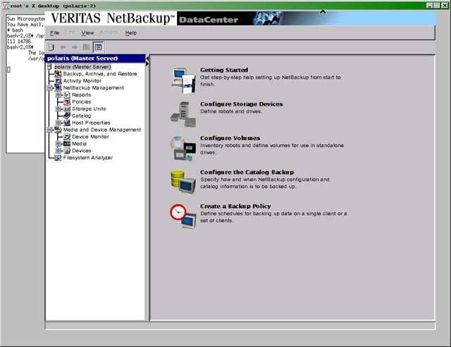

Activity Monitor

Start the NetBackup Administration Console. (see The NetBackup Administration Console)

In the menu tree on the left-hand side of the NetBackup Administration Console, the Activity Monitor will appear, with the Jobs tab showing. The following information is provided:

Job ID: Identifier that NetBackup assigns to each job
Type: Backup, Archive, or Restore
State: Queued - Jobs that are in the NetBackup scheduler queue
Active - Currently active jobs
Re-Queued - Jobs that are back in the NetBackup scheduler
queue because the previous attempt was unsuccessful
Done - Completed jobs (whether successful or not)
Status: The status code of the job (consult this status code when
troubleshooting)
Policy: The backup policy for this job
Schedule: The schedule for this job
Client: The client computer for this job
Media Server: The media server for this job (polaris)
Start Time: The start time for this job
Elapsed Time: The elapsed time for this job
End Time: The end time for this job
Storage Unit: Which tape drive is being used for this job
Attempt: The current attempt number for this job
Operation: For active jobs, indicates the current operation (mounting,
writing, etc.)
Kilobytes: The number of kilobytes that have been written
Files: The number of files that have been written

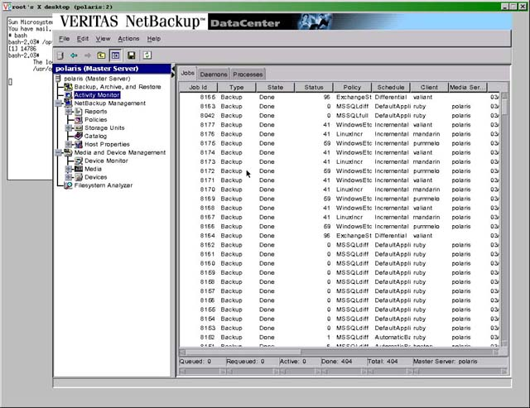

A Status Code of 0 means a successfully completed job with no errors.

A Status Code of 1 means that some files were not backed up, but the
backup process continued and completed. Typically this is not a
problem, as this typically means that a system file was in use when
the backup was occurring, but do check the list of files that were not
backed up to confirm this. To get the list of files, run a report on
Status of Backups during the appopriate time period (see Reports).

On any other status code, the backup did not complete successfully.
Consult the VERITAS NetBackup 4.5 Troubleshooting Guide, Chapter 4 -
NetBackup Status Codes and Messages to find the type of error and the
recommended course of action.

If you wish to cancel a job that is currently running, right click on the process and click Cancel Job from the pop-up menu.

Reports

Start the NetBackup Administration Console. (see The NetBackup Administration Console)

In the menu tree on the left-hand side of the NetBackup Administration
Console, click Reports.

On the right-hand side of the NetBackup Administration Console, the
Reports window will appear.

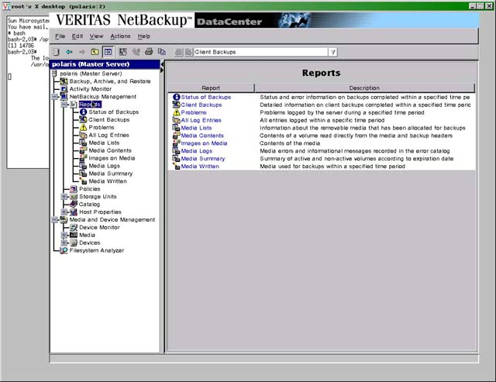

Consult the Description fields, then click on the type of Report that
you want. The Report Settings window will appear.

Select the Date/Time Range desired. Use the drop down menu to select
the Media Server desired (unless you add a new Media Server, this will
always be polaris). Use the drop down menu to select the Client
desired. If there is a specific Job ID for which you wish to have a
report, enter it in the Job ID field.

Now click the Run Report button, and the report will be generated.

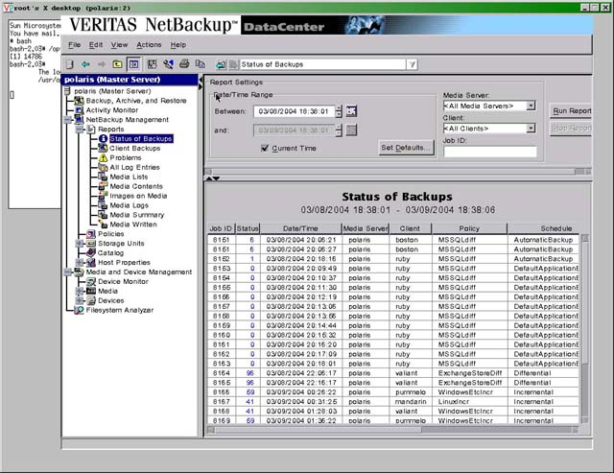

Adding New Tapes To The Library

Go to the library.

At the library display, press the MENU button.

The first menu option should be Door Operations. Press the SELECT button.

Press the SELECT button again to comfirm opening of door.

Once the display indicates that the door can be opened, turn the key
counterclockwise until it stops. Then pull open the door.

Note: The door sticks. Hard. Grab it by the botton (by the metal part
of the door behind the plastic faceplace) and pull it open.

Insert new tapes into the open slots, label side outward, with the arrow
on top (metal disc side down).

Ntoe: Save the plastic containers!

Close the door and turn the key clockwise until it stops.

Log into polaris.

Start the NetBackup Administration Console. (see The NetBackup Administration Console)

Under Media and Device Management, click on Media. The list of tapes will
appear in the right side window.

Right-click in the right-side window, then select Inventory Robot from
the pop-up menu. A large dialog window will appear.

In the Robot Inventory tab, select Perform volume configuration update,
then click Start.

In the Results window, confirm that the new tapes have been added to the
library, then close the window.

To assign new tapes to a volume pool:

Back at the list of tapes, select a tape or tapes that you wish to assign
to a volume pool. Then right-click on the highlighted tapes and select
Change from the pop-up menu. A large dialog window will appear.

Under Volume pool, click New pool, then select the appropriate
volume pool from the drop down menu to the right. Then click Ok to
confirm the change and close the window.

Removing Tapes From The Library

Log on to the NetBackup server (polaris).

Start the NetBackup Administration Console. (see The NetBackup Administration Console)

From the window on the far left, in the Media and Device Mangagement
subheading, click on Media.

Click on the tapes you wish to remove. Hold down the Shift key while clicking to highlight multiple tapes in a row, or hold down the Control key to highlight multiple, non-sequential tapes.

Right-click on the highlighted tapes and select Eject Volume(s) From Robot from the pop-up menu that appears. A dialog window will open to confirm that you wish to eject those tapes. Click on the Eject button in the dialog window.

The dialog window will indicate that the tape eject is occurring. If you are ejecting more than 2 tapes, then you will need to remove the tapes as they arrive in the Media Access Port of the robotic tape library. The Media Access Port has only two slots for tapes, so you need to remove the tapes from the Media Access Port in order to continue ejecting more tapes. A dialog window will appear, indicating that you need to remove tapes from the Media Access Port. When you have done so, click Yes to continue ejecting tapes.

To physically remove tapes from the library:

NOTE: The Media Access Port is called the CAP (Cartridge Access Port) on the library display.

The library display should read CAP: SELECT to open.

Press the SELECT button. The CAP (aka Media Access Port) will pop open. Pull it open all the way and remove the tape(s). Then push the CAP closed.

Manual Backups

Start the NetBackup Administration Console. (see The NetBackup Administration Console)

In the menu tree on the left-hand side of the NetBackup Administration
Console, click Policies. The Policies window will appear in the
right-hand side of the NetBackup Administration Console window.

Click the name of the policy for which you wish to run a backup, then
right click on the name of the policy and select Manual Backup from
the pop-up menu. The Manual Backup window will appear.

Click a schedule to select it, and click on the clients you wish to
back up to select them. Click Ok when you are done. The Backup
Policy Management dialog window will appear, stating that the manual
backup for the policy you've selected has been started. Click Ok.

Restoring A File

Log on to the NetBackup Server (polaris).

Start the NetBackup Administration Console. (see The NetBackup Administration Console)

In the menu tree on the left-hand side of the NetBackup Administration
Console, click Backup, Archive, and Restore.

On the right-hand side of the NetBackup Administration Console, the Backup, Archive, and Restore window will appear. Click the Restore tab. The Restore window will appear.

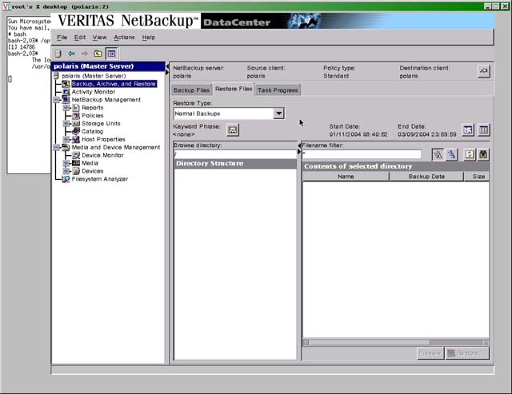

On the top bar of the window, above the tabs, you will see the NetBackup server, Source client, Policy type, and Destination client listed. To the right of Destination client is a button with a hand icon (the Change button) on it. Click that button. (You may need to grab the title bar of the entire window and move it to the left to find the Change button.) The Specify NetBackup Machines window will appear, with the NetBackup Server tab window showing.

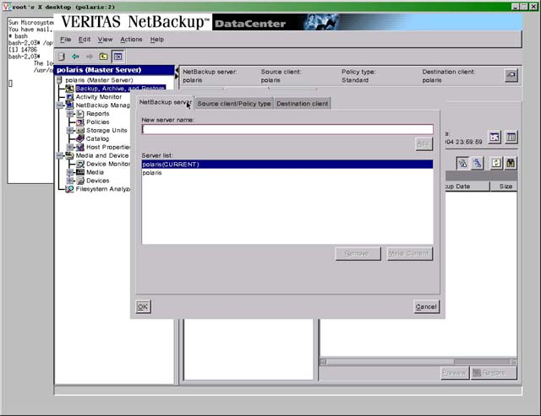

Confirm that the server with (CURRENT) next to it is polaris, then click the Source client/Policy type tab. Enter the name of the client in the New client name: field, then click Add. Then click the name of the client in the Client list and click the Make Current button.

Next, select the appropriate policy type in the Policy type drop down menu. For Windows XP, Windows 2000, or Windows NT, select MS-Windows-NT. For a Microsoft Exchange Server, select MS-Exchange. For a Unix server (Solaris or Linux), select Standard. Then click the Source client/Policy type tab. The Source client/Policy type tab window will appear.

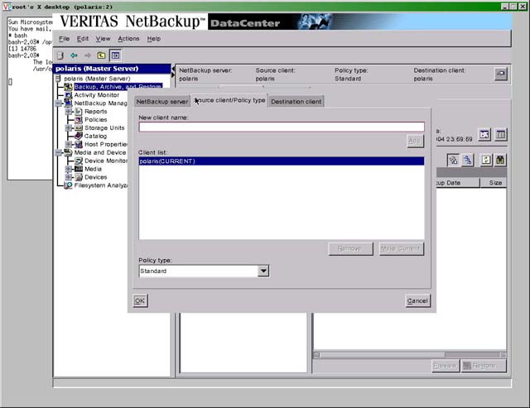

Enter the name of the client in the New client name field, then click the Add button. Then click the name of the client in the Client list and click the Make Current button. Next, select the appropriate policy type from the Policy type
drop-down menu. Then click the Destination client tab. The Destination client tab window will appear.

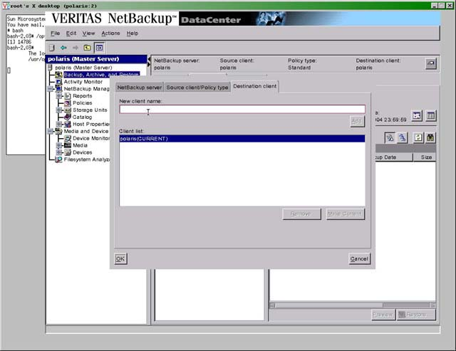

Enter the name of the client in the New client name field, then click the Add button. Then click the name of the client in the Client list and click the Make Current button. Then click the Ok button. You will be returned to the Backup, Archive, and Restore window, with the Restore Files tab window showing.

Confirm that Normal Backups is showing in the Restore Type drop down menu. (check to see if there's anything different that has to be done for Exchange)

On the right side of the Restore tab window, underneath the Change button, the Start Date and End Date are listed. To the right of the Start Date and End Date are two icons. Clicking the left icon (which sort of looks like a calendar) lets you use a calendar to set the range of time in which the desired files are located. Alternately, you may click the right icon to use the backup history to set the range. Once you have selected the range, choose the files you wish to restore using the interface in the botton half of the Restore tab window.

You may change the directory you are browsing by entering the desired directory in the Browse directory field. You may change the filter for finding the desired files by entering a filter into the Filename filter field. To refresh the displayed files in the window, click the button second from the far right of the window, underneath the calendar icon. The button in question (the Refresh button) has an icon consisting of a white square with two green arrows going clockwise.

To select the files you wish to restore, click in the checkbox next to each desired file or folder.

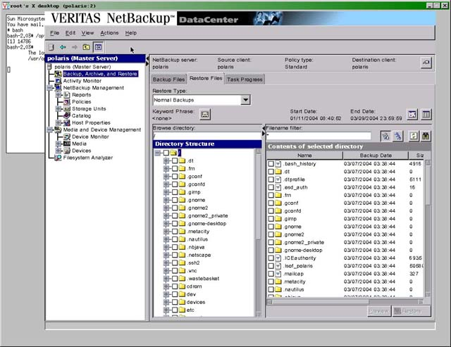

When you are done selecting files, click the Restore button in the bottom right-hand corner of the window. The Restore files window will appear. Confirm that the Restore everything to its original location radio button is selected, then click the Start Restore button.

The Restore dialog window will appear, stating that the restore was successfully initiated. If you wish to view the progress of the restore, click Yes. The Backup, Archive, and Restore window will appear, with the Task Progress tab window showing. Otherwise, click No.

Creating A Backup Policy

Log on to the NetBackup server (polaris).

Start the NetBackup Administration Console. (see The NetBackup Administration Console)

In the menu tree on the left-hand side of the NetBackup Administration
Console, click Policies.

The Policies window will appear. The left-side window is the list of all policies. The right-side window contains the general details of the currently highlighted policy.

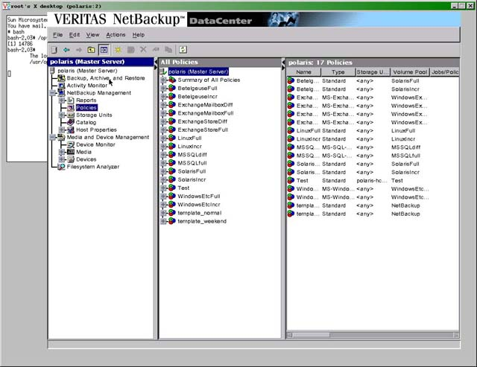

To create a new policy, right-click inside the left-side Policies window, then select New from the pop-up menu. The Add a New Policy window will appear.

Enter the name of the new policy, then click Ok. The Change Policy window will appear, with the Attributes tab showing.

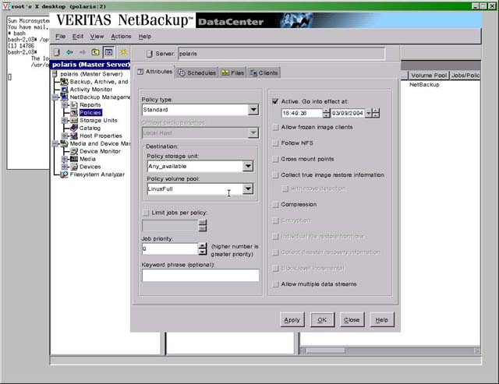

Set the Policy type by selecting one of the option in the drop down menu in the upper-left-hand side. For a Unix client, select Standard. For a Windows 2000 or Windows XP client, select MS-Windows-NT. For a Microsoft Exchange Server client, select MS-Exchange. For a Microsoft SQL Server client, select MS-SQL-Server.

Next, set the Policy storage unit by selecting one of the options in the appropriate drop down menu. Unless some sort of special case comes up, you'll simply want to select Any_available.

Next, set the Policy volume pool by selecting one of the options in the appropriate drop down menu. This is the group of tapes in which you want to store the data. For example, if you were backing up data from a Linux client, you would select LinuxFull or LinuxIncr, depending on whether you wanted to perform full or incremental backups, respectively.

If you wish, you may change the Job priority by increasing or decreasing the number in the Job priority field. The higher the number, the higher the priority for the job.

If you wish to make the policy active, click in the Active checkbox, and set the time and date at which you want to the policy to become active. IMPORTANT: No backups for this policy will occur until the policy is made active.

Generally speaking, you shouldn't need to check any of the other checkboxes in the Attributes tab.

Next, click the Apply button.

Next, click the Schedules tab. The Schedules tab window will appear.

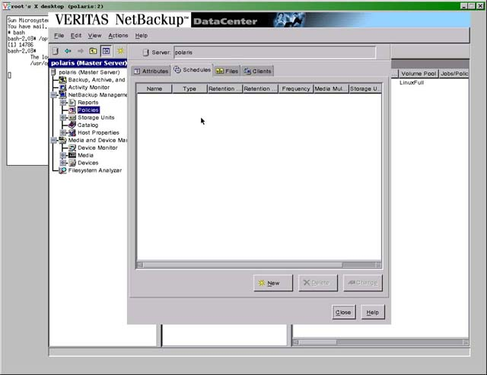

Click New. The Schedule Attributes tab window will appear.

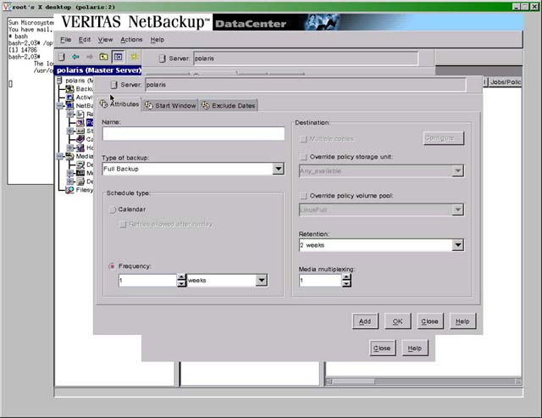

Enter the name of the schedule in the Name field. Note that spaces and special characters may not be used in the name.

Set the type of backup desired by selecting one of the options in the Type of backup drop down menu.

Set the frequency at which the backup is desired.

Set the Retention (the duration for which you want to retain the data before discarding it) by selecting one of the options in the Rentention drop down menu. (suggestion: one year)

Next, click the Start Window tab. The Start Window tab window will appear.

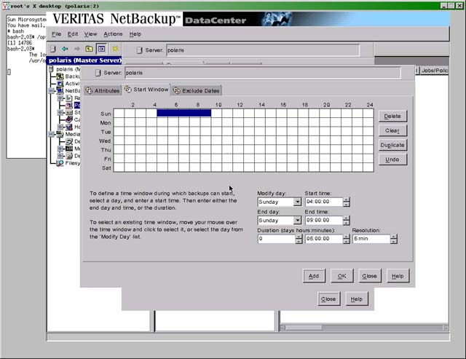

Using the drop down menus, set the day and time at which a backup may begin. Then set the time period during which a backup may begin during that day by entering the time period in the Duration fields. If you wish to add another day during which a backup may occur, go back to the Modify day drop down menu, select a new day and start time, and a new duration.

If you wish, you may also choose specific dates when you do not want backups to occur. To do this, click on the Exclude Dates tab, and click on the dates in the calendar which you want to exclude from the backup schedule.

When you are finished creating the schedule for this policy, click the Add button. You will be sent to an unfilled Add Schedule window. You may create another schedule if you wish. If you do not wish to do so, click the Close button. You will be sent back to the Change Policy window.

Click the Files tab. The Files tab window will appear.

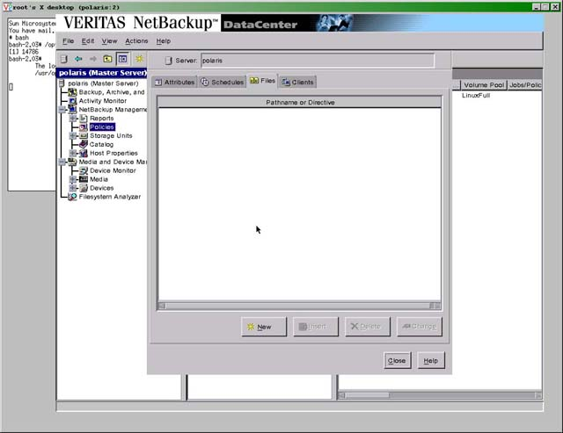

Click the New button. The Add File window will appear.

Set the pathname of the directory you wish to back up by selecting one of the options in the Pathname or directive drop down menu, and click the Add button to the right. Alternately, you may specify the directory you wish to back up by typing it in the field and clicking the Add button to the right. If you wish to back up all local drives on the client, just select ALL_LOCAL_DRIVES. (windows vs. unix?)

When you are done selecting the files and directories you wish to back up, click on the Clients tab. The Clients tab window will appear.

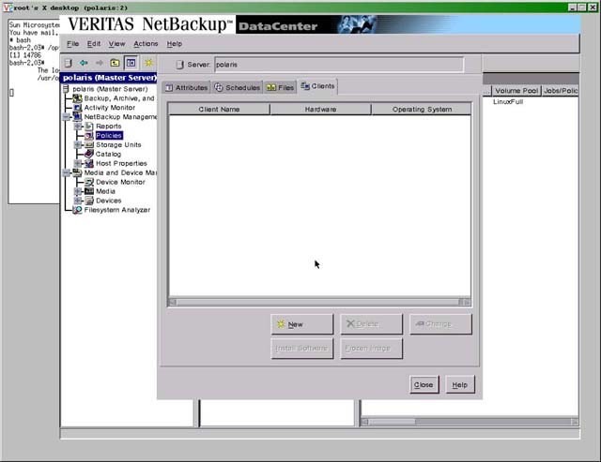

Click the New button. The Add Client window will appear.

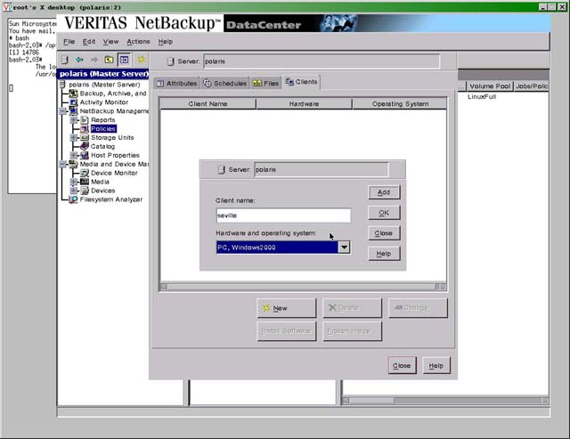

Enter the name of the client in the Client name field.

Set the hardware and operating system of the client by selecting one of the options in the Hardware and operating system drop down menu, then click the Add button.

You may continue to add clients the same way. When you are done, click the Close button and the policy creation will be complete.

To modify an existing policy, click the desired policy in the left-hand side Policies window to select the policy, then right-click on that policy and select Change from the pop-up menu. The Change Policy window will appear. Be sure to click the Apply button after making changes in the Attributes tab to make sure that those changes are applied.

Adding New License Keys

Start the NetBackup Administration Console. (see The NetBackup Administration Console)

In the left-hand window, click on polaris at the top of the tree.

In the top menu bar, click Help, then select License Keys from the drop down menu. The NetBackup License Keys window will now appear.

Click on New.

Enter the new License Key, then click Ok.

User-Directed Backup for Unix

Log on to the NetBackup server (polaris).

Run the following command:

# /opt/openv/netbackup/bin/bp

The NetBackup 4.5 GA Backup Utility Main Menu will appear.

At the ENTER CHOICE prompt, press b for Backup.

The Backup Menu will appear.

At the ENTER CHOICE prompt, press b for Backup Files and Directories.

The Selections interface will appear.

To brows through the files on the client, use U to move up, D to move
down, I to Zoom In (move down the directory tree), and Z to Zoom Out
(move up the directory tree). To move more quickly up or down, use
F (Fwd) to move down the directory tree a page at a time, and B (Back)
to move up the directory a page at a time. To select a file, press S.
When you are done selecting files, press O for Ok.

The Backup of Files and Directories menu will appear.

At the ENTER CHOICE prompt, pess i to Initiate Backup.

You will be asked if you would like to use a user progress log. You
don't need to, so press n at the prompt if you wish. If you would
like to use a user progress log, press y. If you press y, then you
will be asked to enter the Progress File Path. Just press Enter
to use the default file.

The Backup will be initiated, so press any key to continue.

The Backup of Files and Directories menu will appear.

Press q to Quit Menu.

The Main Menu will appear.

Press q to Quit.

User-Directed Backup For Windows

From the client machine, click Start, then Programs, then VERITAS NetBackup, then Backup, Archive, and Restore

The NetBackup client application will launch and appear.

From the menu bar, click Select for Backup.

In the directory tree, click in the boxes of the files and folders you wish to back up.

In the menu bar, click Actions.

Click Start Backup of Marked Files.

The Specify Backup Options window will appear.

Click Start Backup.

Installing NetBackup On A Unix Client

Log on to the client machine. Insert the installation cd, then mount it to
/mnt/cdrom.

cd to the directory containing the installation cd (/mnt/cdrom) and type the following command:

./install

The VERITAS Installation Script will run, and the Installation Options
menu will appear.

At the Choose an option prompt, enter 2 for NetBackup Client Software.
Yes, you want to install the NetBackup Client Software for this client,
eo enter y at the next prompt.

At the Enter the name of the NetBackup server prompt, enter polaris.

At the Enter the name of this NetBackup Client prompt, enter the name
of the client.

The NetBackup client software will now install. Once it's done, the
Installation Options menu will appear again. Enter q at the prompt
to exit the installation script.

Installing NetBackup On A Windows Client

Insert the disc titled VERITAS NetBackup DataCenter 4.5/VERITAS NetBackup BusinessServer 4.5 for Windows. The installation application should launch and appear.

From the Main Menu on the left side of the installation application, select NetBackup.

On the right side of the installation application, click NetBackup Installation.

On the right side of the installation application, click Start NetBackup Client Installation.

Click Ok to continue. The Setup Wizard will appear.

Click Next to continue.

Select Install to this computer only, then click Next to continue.

Select Typical, then click Next to continue.

Enter the client name in the Client Name: field. For example, if the client is named "seville", then enter seville. (NOT seville.orangeimagineering.com)

In the Master Server Name: field, enter polaris.

Click Next to continue.

Click Install. The NetBackup client software will now install.

Click Finish.

If the client does not use a database, then continue with the section entitled Modifying the Registry. If the client does use a database, then continue with the section entitled Installing Database Agents.

Modifying the Registry

The default settings for the Open Transaction Manager software (aka OTM – see Terminology for a description) are inadequate and need to be changed on the client machine. Note that OTM only runs on non-Exchange, Windows clients, and not on Unix-based clients. Do the following:

On the client machine click on Start, then click on Run. Enter the following command:

regedt32.exe

The Registry Editor will launch and appear.

From the tree on the left, expand HKEY_LOCAL_MACHINE by clicking
on the + sign.

Expand SOFTWARE, then expand VERITAS, then NetBackup, then CurrentVersion, then Config.

Click on Config

Right click on OTM_Error_Control, then click Modify in the pop up menu that appears. In the value data field, enter 1. This will set OTM to continue the backup process with the rest of the files on the client if there is a problem backing up a file that is currently in use.

Right click on OTM_Cache_Size_Max, then click Modify in the pop up menu that appears. In the value data field, enter 592. This will increase OTM’s cache size to the maximum allowed size of 500 MB, which will help avert cache overflow problems.

You are now done and may exit the Registry Editor.

Installing Database Agents

If you are installing NetBackup software on a client that uses a database, such as MSSQL, Oracle, or Exchange, you will also need to install a database agent on that client.

Insert the disc titled VERITAS NetBackup DataCenter 4.5/VERITAS NetBackup BusinessServer 4.5 for Windows.

The installation application will launch and appear.

From the Main Menu, select Database Agents.

On the right side of the installation application, click Database
Agent Installation.

Click on the Database Agent that you would like to install.

The InstallShield Wizard will appear. Click Next to continue.

Select I accept the terms in the license agreement, then click
Next to continue.

Click Install. The Database Agent will now install.

Click Finish.

Troubleshooting

Status Code 0

No problems. Everything backed up fine.

Status Code 1

One or more files were in use while the backups were occuring, and could not be backed up. All other files backed up fine. Generally, this error message can be ignored, since the files that are in use are system files that typically don’t change, and are backed up every day. However, if this error occurs during a Microsoft Information Store or Mailbox backup for a Microsoft Exchange Server, then immediately contact the system administrator (Tom Mullaly) to see if there is something wrong with the Exchange server (nova). Chances are that there was a lot of activity happening on the Exchange server. Run a manual backup of the Exchange server, preferably in the evening when load on the server is lower.

Status Code 11

Open Transaction Manager (OTM) cache overflowed. Backup halted. Resolve by increasing cache size, and setting the error state to “keep backing up” on the client, then run a manual backup of the client. (see: Windows Client Installation for the appropriate registry modifications)

Status Code 41

Connection timed out trying to reach the client machine. We’ve gotten this error when the NetBackup installation disc was NFS-mounted on the client and the installation disc was un-NFS-mounted on the NetBackup server (polaris) without first unmounting the NFS mounts on the client machine. To resolve the problem, reboot the client machine.

Status Code 54

Timed out connecting to the client. Consult the system administrator (Tom Mullaly) to find out what is wrong with the client machine, as it may be shut down or offline.

Status Code 71

None of the files in the file list exist. This has happened when the Outlook backup files weren’t specified properly.

Status Code 84

Media write error. This happened with a physical problem with the robotic tape library, where a tape was stuck in the drive. Once the problem is resolved, run a manual backup of the client.

Status Code 96

You’re out of tape space for that backup profile. Assign more tapes to that volume pool. Order more tapes. Insert more tapes. Run a manual backup for that client.

Status Code 196

Backup window closed. Either you need to extend the backup window, or there was another error with a different backup that caused backups to be halted. If there was another error, resolve that error, then manually run a backup for the client that got the 196 error.

Status Code 246

No active policies in the configuration database are of the correct client type. The policy was switched to “inactive”. Switch it back to “active”. Run a manual backup of the client afterwards.

